**Only If afscme_oltp4 Replication on AFSSQL1604 is out of synch or failed do following steps:**

1.Contact AWS/DW team and ask them to stop their Replication from Publishing to DW.

2.Connect to Remote server to server 10.64.82.220  using afscme\sql16admin account

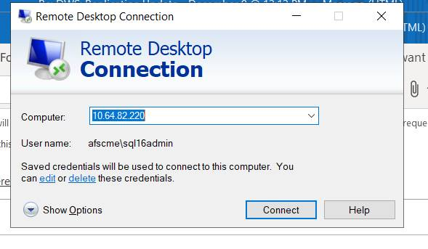

3. Connect to SQL SERVER by MS SQL Management studio

And Connect to AFSCMEENT-DB7V

4.Connect to afssql1604 so that Publication and Subscription are “talking” to each other

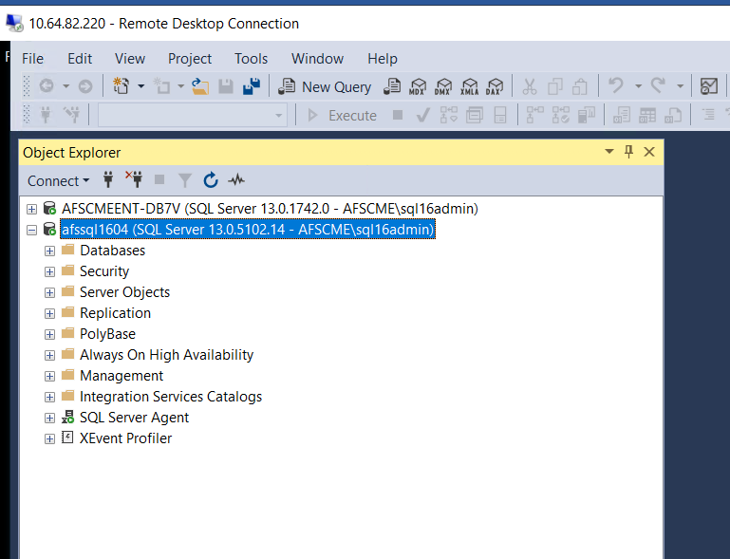

5.go to AFSSQL1604 **Replication**

6. right click on **Replication and select Publisher Properties**

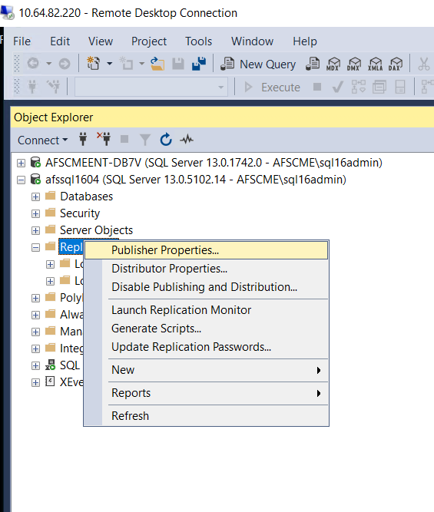

7.On Publisher Properties select Publication Databases

And **uncheck/de-select** afscme_oltp4 from the list of Transactional

Click OK.

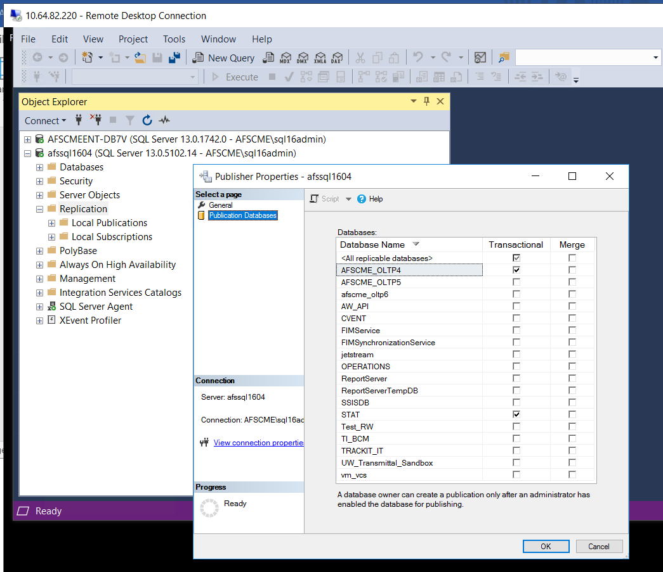

**This step is releasing the lock that DW Publication was having on AFSCME_OLTP4 on afssql1604 preventing replication to fix itself and pickup transactions.**

**We removed OLTP4 DB on 1604 from PUBLICATION databases on  publisher properties –so it is not locked by AWS PUBLICATION.**

8. to check if it is running, on afssql1604 got to LOCAL SUBSCRIPTIONS

Right click on **[AFSCME_OLTP4] - [AFSMEENT-DB7V]. [AFSCME_OLTP4]** and select

VIEW Synchronization Status—it should be running and delivering transactions

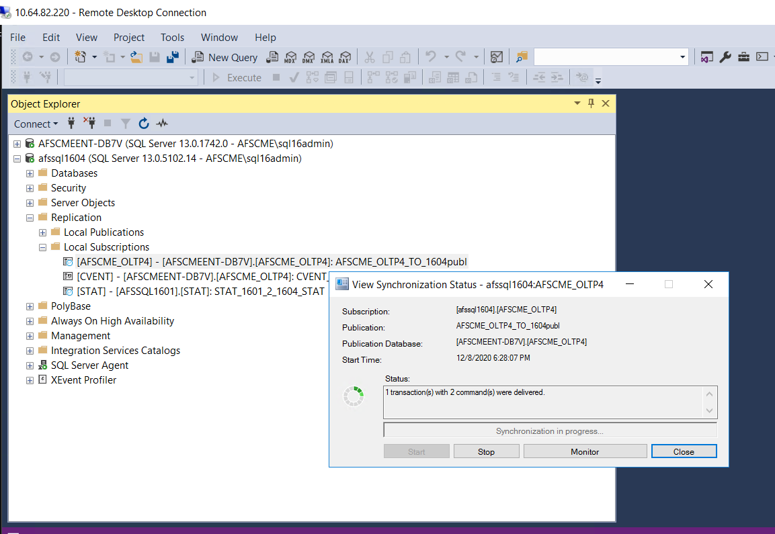

9.go to Replication—Launch Replication Monitor to see if all Publications/Subscriptions are GREEN meaning running

On a left sides are Publications, on a right –subscription—see if everything is running by View Details

